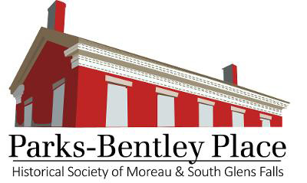
Group Tour/Program Registration Form
To schedule group programs to be presented on-site at Parks-Bentley Place or at your own location, or to arrange a group tour, please contact us at parksbentleyplace@gmail.com or call Nancy Purinton at 518-636-3856 (purinton73@gmail.com).
The following information is needed for scheduling. We ask that you complete this form, save a copy for your records, then email to purinton73@gmail.com.
Desired Program or Tour: Click or tap here to enter text.
Requested Program Date: Click or tap here to enter text.
Preferred Presentation Time:Click or tap here to enter text.
Number in Group: Click or tap here to enter text.
Place Program is to be Presented: Please check one.
__ Parks-Bentley Place or
__ Name of Organization Click or tap here to enter text.
Street Address Click or tap here to enter text.
City Click or tap here to enter text. ST Click or tap here to enter text.
Zip Click or tap here to enter text.
Contact Name Click or tap here to enter text.
Phone Click or tap here to enter text.
Email Click or tap here to enter text.
The cost for each group program or group tour is as follows:
School other children's groups: $2 per person
Adult Groups: Flat rate of $50 for adult groups (maximum 35 individuals)
Note: For groups wishing to make jam as part of the "Food for Thought" Program, there is an additional fee of $4 per person to cover the cost of supplies.

Historical Society of Moreau and South Glens Falls, Parks-Bentley Place
53 Ferry Boulevard, South Glens Falls, NY 12803 parksbentleyplace.org

